BEGINNING OF TERM ONE EXAMINATION 2024
PRIMARY TWO
LITERACY ONE

Time allowed: 2hour 15 minutes

My name is _________________________________________________
School _____________________________________________________

1. Who heads a school?
________________________________________________________
2. Why do we wear clothes?
________________________________________________________
3. How can you care for plants?
________________________________________________________
4. Circle one common disease.
polio cough measles cholera

5. Name one wild animal which eats other animals.
________________________________________________________
6. What do we get from bees?
________________________________________________________
7. How do we preserve food?
________________________________________________________
8. Pilot is to aeroplane as captain is to ____________________.
9. Too much rain causes _____________. (drought, floods)
10. Why do people make mats?
________________________________________________________
11. Name these things found in a classroom.

12. Write down two types of seasons.
(a) __________________
(b) __________________

13. Fill in the missing letters.
(a) ba__ket
(b) t__n

14. Name the weather when we use these things.

15. Underline the things that have life.
(a) train, elephant, house
(b) block, rock, fish
(c) hat, hoe, hen, hip

16. Name two main groups of living things.
(a) ________________________________________________
(b) ________________________________________________
17. Draw and name two basic needs of a family.

18. Choose any two symbols of a school.
book flag pens
badge flowers cooks

- _________________
- _________________

19. What is the use of these tools at home?
(a) 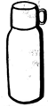 ______________________________

(b) 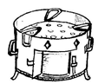 ______________________________

20. Write the animal sounds.
(a) dog _________________
(b) bird _________________

21. Write True or False at the end of a sentence.
(a) Wind is moving air. ______________
(b) A Zebra-crossing is an animal. ____________
(c) A carpenter makes furniture. ____________

22. Underline the things that give us peace.
love abusing obedience
hatred respect fighting

23. Match people to their places of work.
(a) Doctor garage
(b) Teacher hospital
(c) Mechanic airport
school

24. Name the main parts of the plant below.
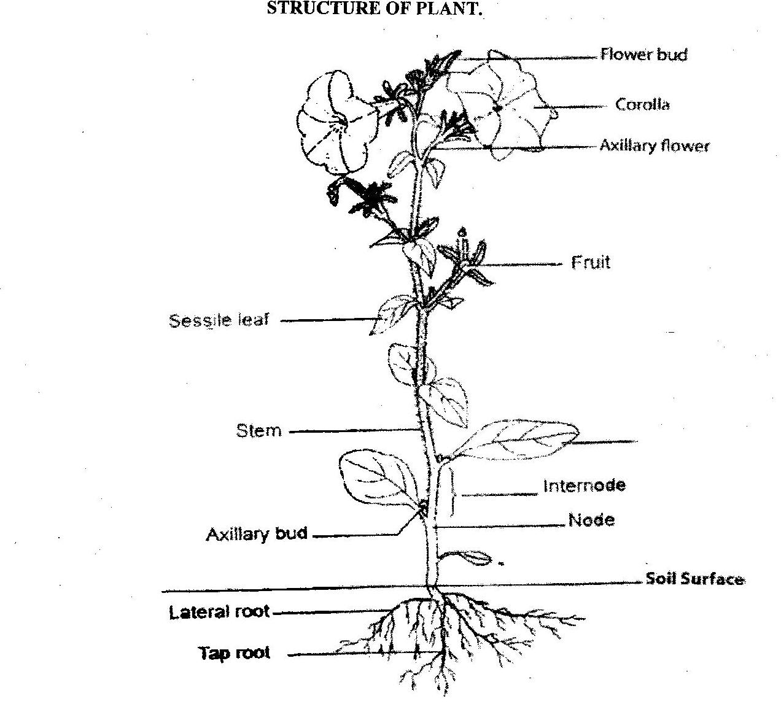
a________________
b________________
c________________
a
b
c
25. A cow is a domestic animal. Write three things we get from a cow.
(a) ________________________________________
(b) ________________________________________
(c) _______________________________________
26. Read and answer correctly.
(a) I am an animal. My meat is called fillet. My young one is a fry. I live in a lake. What am I?
You are ____________________________________________

(b) I am found on your body. You use me to touch. You also use me to write. What am I?
You are ____________________________________________

- I have three hands. One hand is short. Another hand is long. All my hands move around. The thin hand moves fast. I make tik-tak, tik-tak, tik-tak sound. What am I?
You are ___________________________________

27. Who created all birds?
__________________________________________

*** Best Wishes *
P.2 B.O.T ONE 2024
- Headteacher/Headmaster
- To be warm/To cover our body/To be smart.
- By watering/By weeding/By spraying/By staking/By pruning
- Cough
- Iron/leopard
- Honey/wax
- Cooking/smoking/keeping it in a fridge.
- Ship
- Floods
- To sell them and get money/To sit on them.
- Pencils books
- Wet season (b) Dry season
- (a) s (b) i
- (a) sunny
(b) rainy/sunny
- (a) elephant (b) fish (c) hen
- (a) plants (b) Animals
- Mark clear pictures.
- (a) badge (b) flag
- (a) cutting (b) combing hair
- (a) barks (b) sings
- (a) True (b) False (c) True
- Love, obedience, respect
- Doctor – hospital
Teacher – school
Mechanic - garage
- Leaf, stem, root
- Milk/meat (beef)/skin
- (a) a fish
(b) a hand
(c) a clock/watch
- God/Allah

